Plugging into the Future: An Exploration of Electricity

Consumption Patterns

**1. INTRODUCTION**

**1.1 Overview**

Usually, a good dashboard and design facilitates good experiences. The Electricity consumption shares the information that how we use electricity in year 2019-2020 our   
day-to-day life. Hence a good dashboard reveals its important. This project investigates the consumption of electricity and implementation of dashboard which is representing the importance of consuming electricity. This project aims to make the use of the advantages of electricity to develop a smart dashboard based on the usage of electricity.

To implement a graphical dashboard, a platform can be considered is windows. To eliminate the complicated issues on consumption of electricity, this project utilized software Tableau, MySQL on windows to develop the dashboard. Due to this feature, the convectional dashboards and stories can be created. Therefore, the presented one has quicker information and more reliable information representation.

**1.2 Purpose**

By providing access to electricity, the analysis can help to improve the quality of life for people living in areas without access to electricity, including providing access to lighting, heating, and cooling, and powering essential services such as hospitals and schools. By understanding consumption patterns and trends, the analysis can help businesses identify market opportunities and develop strategies to meet the growing demand for electricity in India.

**2. PROBLEM DEFINITION & DESIGN THINKING**

The empathy map and Ideation & Brainstorming prepared by Mural template, they are;

**2.1 Empathy map**

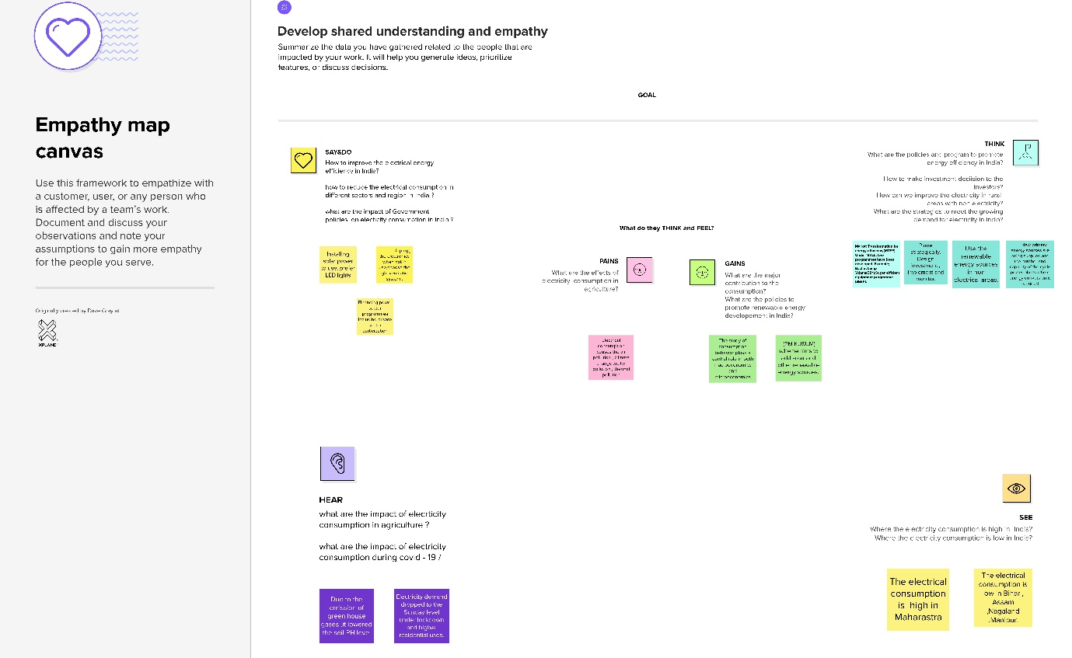

**2.2** **Ideation & Brainstorming Map**

**3. RESULT**

The results contain the dashboard, story, and web integration:

**Dashboard1**

**Dashboard2**

**Dashboard3**

**Story**

**Web Integration**

The result of the project is integrated with the website, the link is:

<file:///E:/Electricity%20consumption/Electricity%20consumption%20edited/index.html>

**Home Page**

**Dashboard**

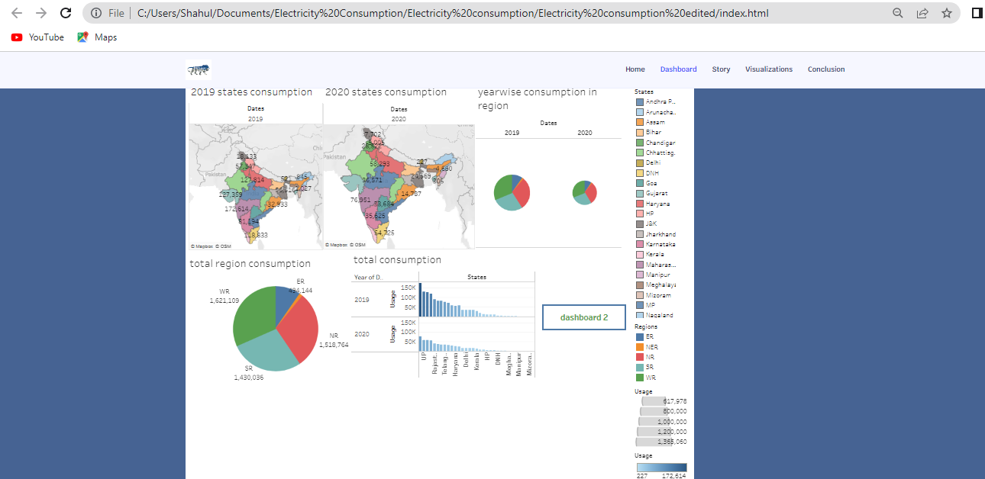

**Story**

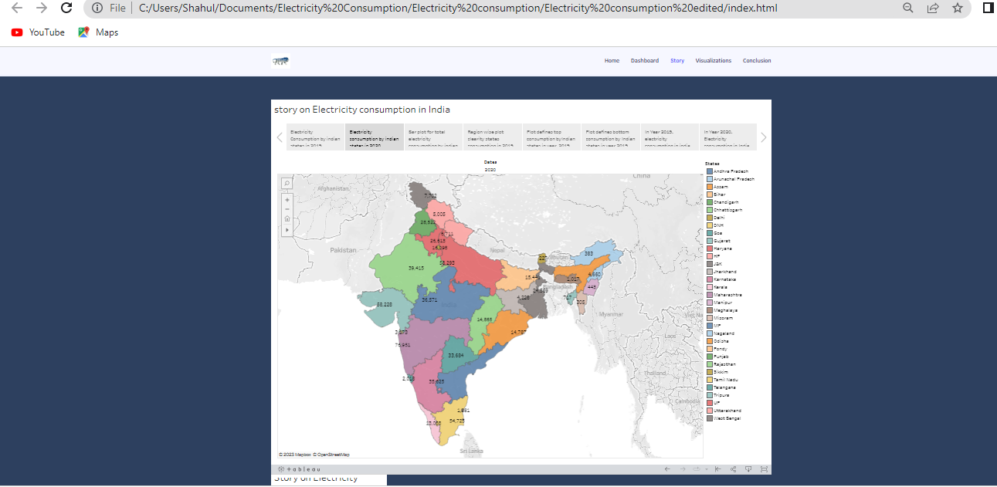

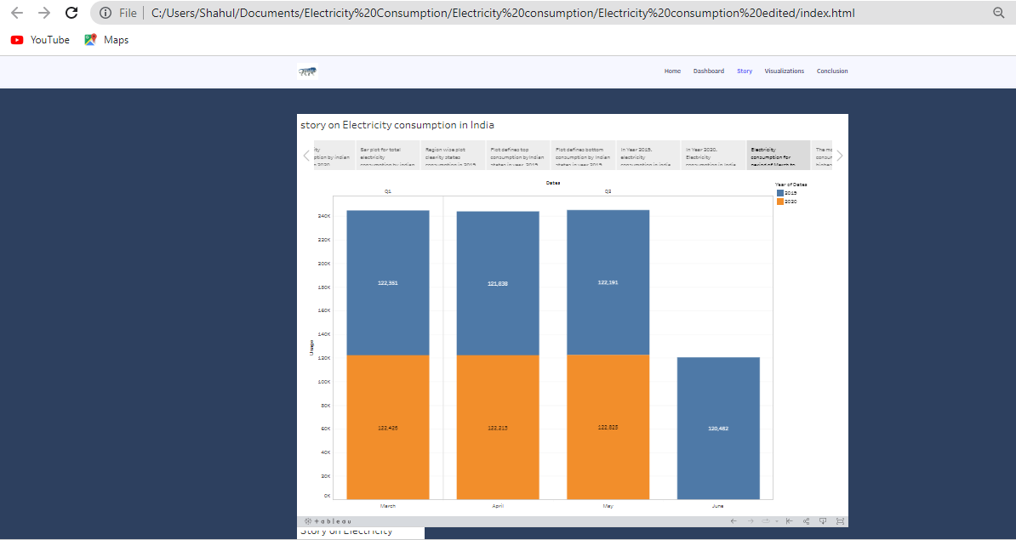

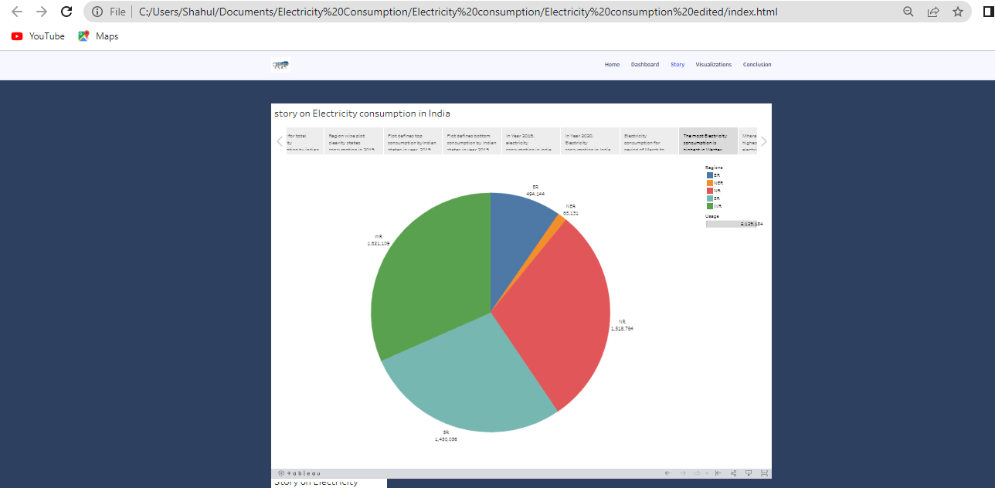

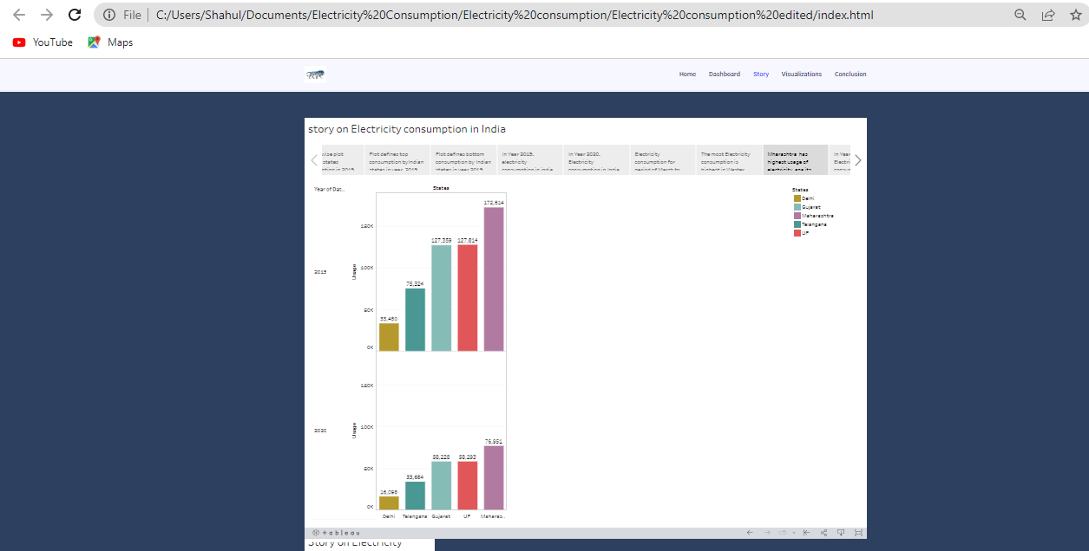

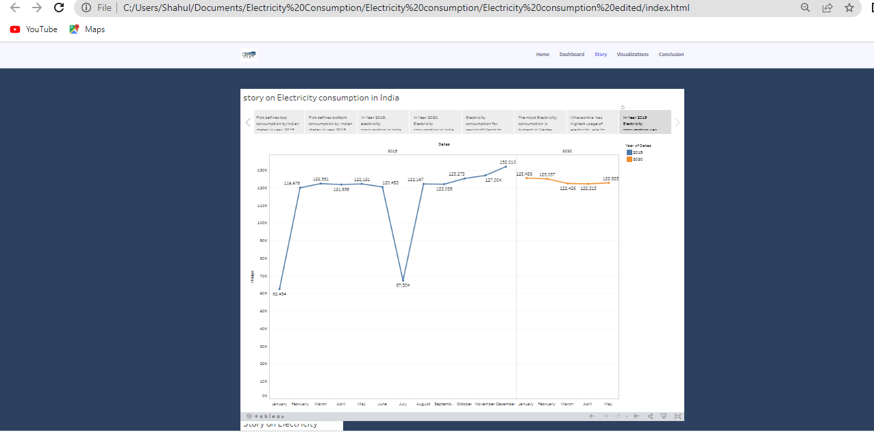

**4. ADVANTAGES AND DISADVANTAGES**

**Advantages**

* + The dashboards and story can be used to identify the areas where consumption in high and where it is low.
  + The dashboards ensure that the information is easily understandable and actionable.
  + Story is used to presenting data and analysis in narrative format, making the information easier to understand.
  + From consumption patterns, we should improve the electricity in northeast areas.

**Disadvantages**

* We must control the consumption of electricity in high level usage areas like west regions, north regions.
* Exhaustion of renewable energy affects the electricity production.
* Introduction of electrical appliances in low level areas improves the electricity consumption.

**5. APPLICATIONS**

* Using the dashboard and story, we can improve the energy efficiency in different sectors and regions.
* Consumption patterns are very useful to improve and reduce the consumption where it is low and where it is high.
* By understanding consumption patterns and charts, develop the strategies to meet the growing demand for electricity in India.
* The dashboard shows that electricity consumption is very low in Sikkim which is in east region. We should improve the providence of electricity in that region and control the extremely used places.

**6. CONCLUSION**

* Electricity is a very important application. It should be saved because it is not at all free.
* In this project, we analysed the electricity consumption in India from 2019-2020 by using the dataset which contains a record of electricity consumption in each state of India. Here we are analysed the consumption of electricity in region wise state wise and overall electricity consumption in India.
* We are analysed the electricity consumption by understanding the problem, extracted the data from database, prepared the data for visualization.
* Designed a dashboard for make the story for presenting a data and analytic is narrative format, performance testing , proceed the web integration .
* Finally, we prepared a video for the project demonstration and created the documentation about project (electricity consumption).

**7. FUTURE SCOPE**

* Prior to the global pandemic India's energy demand was projected to increase by almost 50 percentage between 2019 and 2030, but growth over this period is now closer to 35 percentage in the step and 25 percentage in the delayed recovery scenario.
* In the stated policies scenario global electricity demand grows at 2.1 percentage per year to 2040, twice the rate of primary energy demand. This raises electricity's share in total final energy consumption from 19 percentage in 2018 to 24 percentage in 2040. Electricity demand growth is set to particularly strong in developing economies.